**Department of Computer Science and Engineering**

|  |  |
| --- | --- |
| **Course Code:CSE422** | **Credits:** |
| **Course Name: Artificial Intelligence** | **Prerequisite:** CSE111, CSE221 |

**Lab 09**

**Genetic Algorithm**

1. **Lab Overview:**

The students will solve N-Queen problem using python programming and visualizing the evolution performance.

1. **Learning Objective:**
   1. Introducing the 4-Queen problem
   2. Solution of 4-Queen problem in Backtracking approach
   3. Demerits of Backtracking approach
   4. Introducing 8-Queen problem
   5. Discussion on Genetic Algorithm
   6. Solution of 8-Queen problem using GA
2. **Lesson Fit:**

There is pre-requisite to this lab: CSE111, CSE221. You should have intensive Programming Knowledge and capability to understand algorithms.

1. **Acceptance and Evaluation**

Students will show the output using different datasets and python code. They will be marked according to their lab performance. The main evaluation criteria will be based on project report and demonstration.

1. **Learning Outcome:**

After this lab, the students will be able to:

* 1. Demerits to solve N-Queen problem using Backtracking approach.
  2. Solve the N-Queen problem using Genetic Algorithm

1. **Activity Detail**

* **Hour: 1.0 - 2.0**

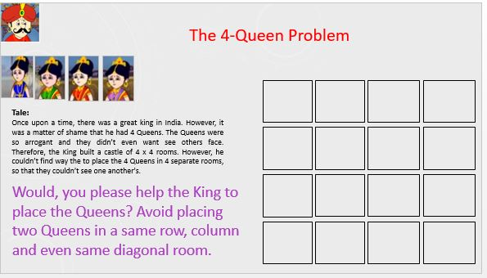

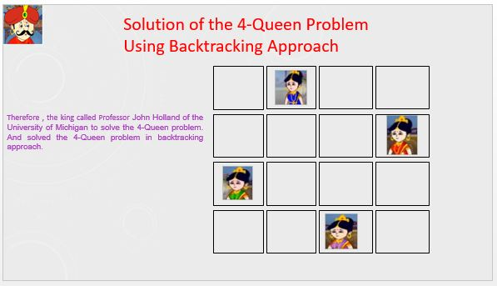

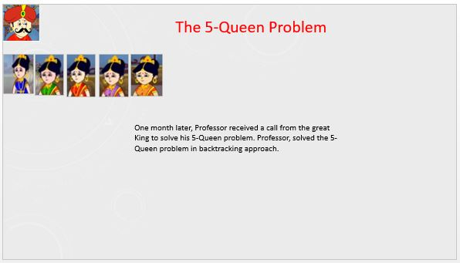

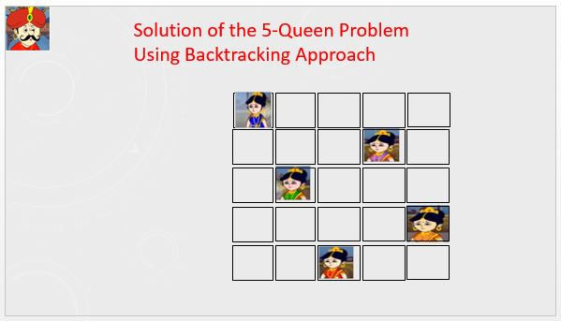

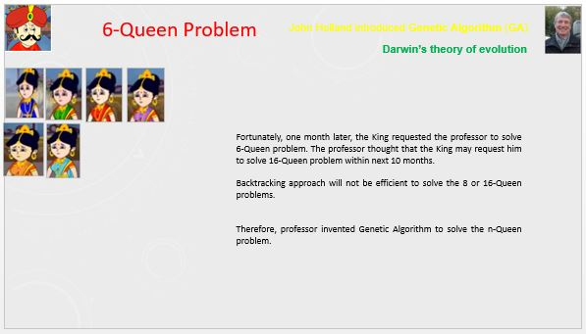

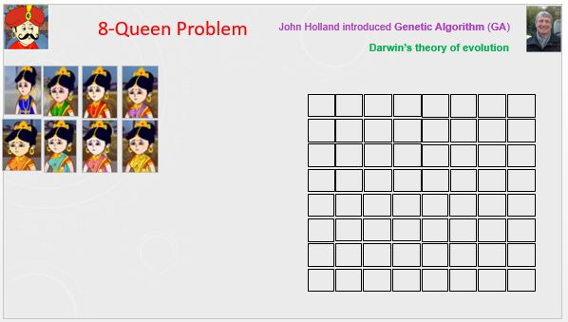

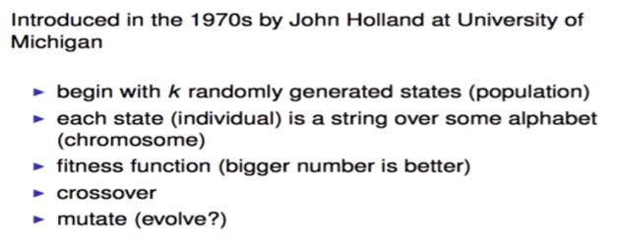

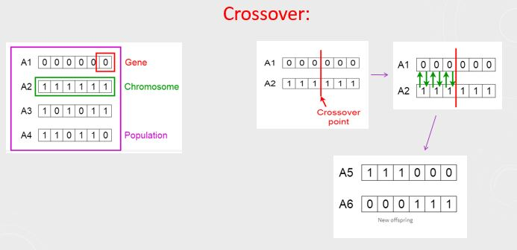

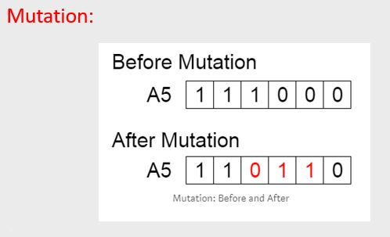

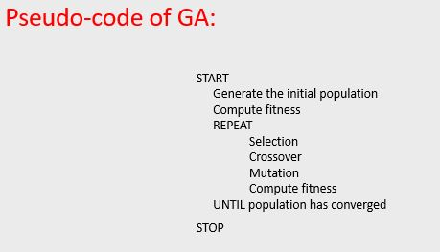

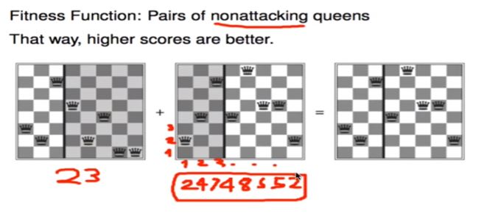

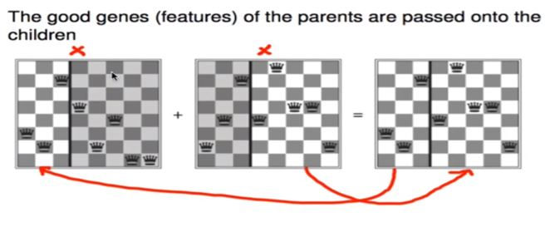

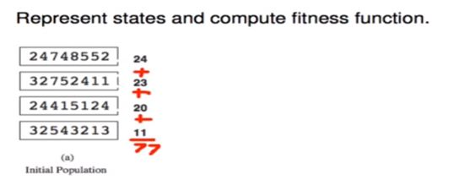

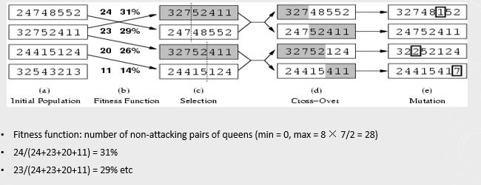

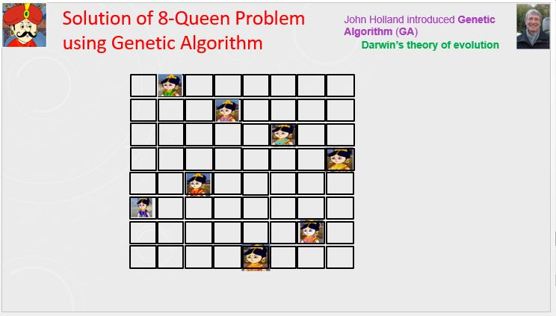

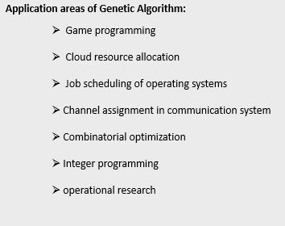

* **Hour: 2.0-3.0**

(It is Not a Group Task, Try Individually)

**Marks: 10**  **Time: 50 minutes**

**Task 1**: Implement N-Queen problem using Genetic Algorithm in python programming.

**Task 2**: Visualize the evolution through plotting the changes of fitness values, and the variances of fitness values for convergence.

Hints: Take help from Prateek Joshi’s Book chapter 8, you can follow Covariance Matrix Adaptation Evolution Strategy (CMA-ES).

Evaluation Process (VIVA and Written answers): You have to explain your program and show your work to the Lab Instructor. Instructor may ask you some questions to evaluate your knowledge and expertise level.

---End---